The Official site where you can keep track of their status with the Attorney General is at: http://www.sos.ca.gov/elections/elections_j.htm

http://www.wethepeopleusa.us/

We The People
CALIFORNIA INITIATIVES

The following initiatives are pending approval at the California Attorney General Jerry Brown's office. Once approved, circulation of Petitions of the initiatives sponsored by We the People Pets will be circulated for signatures.
Initiative Measure To Be Submitted Directly To The Voters
The Attorney General of California has prepared the following title and summary of the chief purpose and points of the proposed measure:
TO THE HONORABLE SECRETARY OF STATE OF CALIFORNIA
We, the undersigned, registered, qualified voters of California, residents of __________________County, hereby propose amendment relating to the declaration of property rights, and Petition the Secretary of State to submit the same to voters of California for their adoption or rejection at the next succeeding primary or general election, or at any special statewide election held prior to that primary or general election, or as otherwise provided by law.
The proposed Constitutional Amendment,
Animal Property Act:
CALIFORNIA CONSTITUTION - ARTICLE 1
DECLARATION OF RIGHTS
The state of California, counties, cities and all governmental entities within the state shall recognize pet animals, animals used for agricultural purposes as well as other animals owned by citizens as property and shall not enforce or enact any law or ordinance language that abridges this mandate enacted by the citizens of the State of California.
This Amendment shall become effective immediately upon its approval by voters.
Submitted by Jill Holt
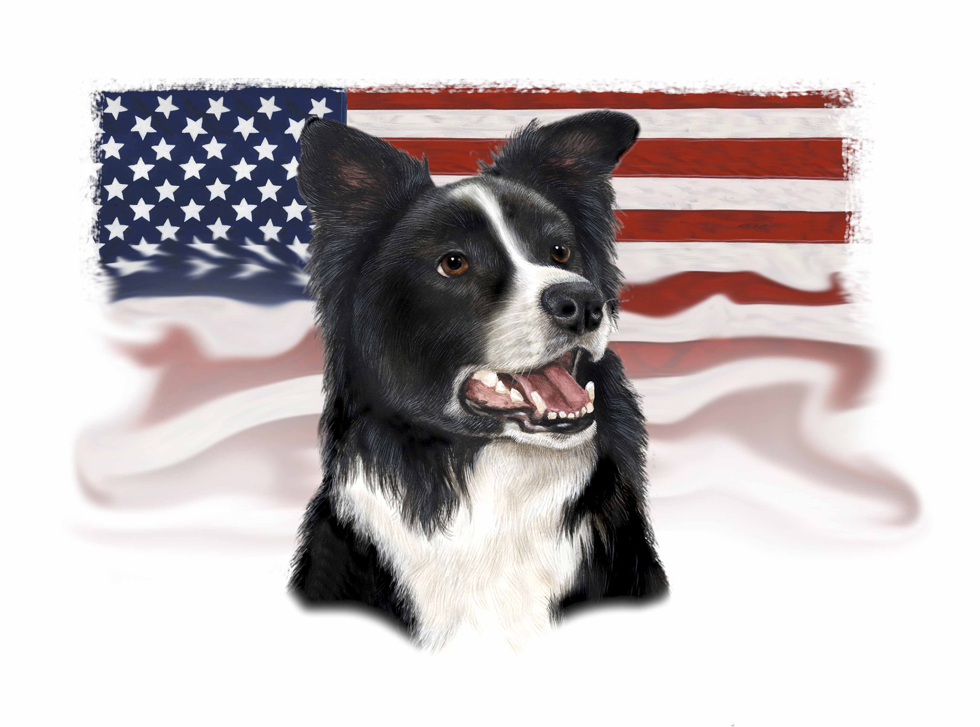
Initiative Measure To Be Submitted Directly To The Voters
The Attorney General of California has prepared the following title and summary of the chief purpose and points of the proposed measure:
TO THE HONORABLE SECRETARY OF STATE OF CALIFORNIA
We, the undersigned, registered or qualified voters of California, residents of __________________County, hereby propose amendment relating to protection against mandated sterilization, and Petition the Secretary of State to submit the same to voters of California for their adoption or rejection at the next succeeding primary or general election, or at any special statewide election held prior to that primary or general election, or as otherwise provided by law.
The proposed Constitutional Amendment,
Freedom Against Sterilization Act:
CALIFORNIA CONSTITUTION - ARTICLE 1 DECLARATION OF RIGHTS
The State of California, cities, and counties, or any governmental entity within the state shall not enact or enforce any law within the state that would coerce by any means or financial penalty or mandate the sexual sterilization by any means, either, permanent or temporary, of any human or animal. There shall be no law(s) or ordinance language enacted that abridge this mandate enacted by the citizens of the State of California.
This Amendment shall become effective immediately upon its approval by voters.
Submitted by Dianne Margaret Hedgcock
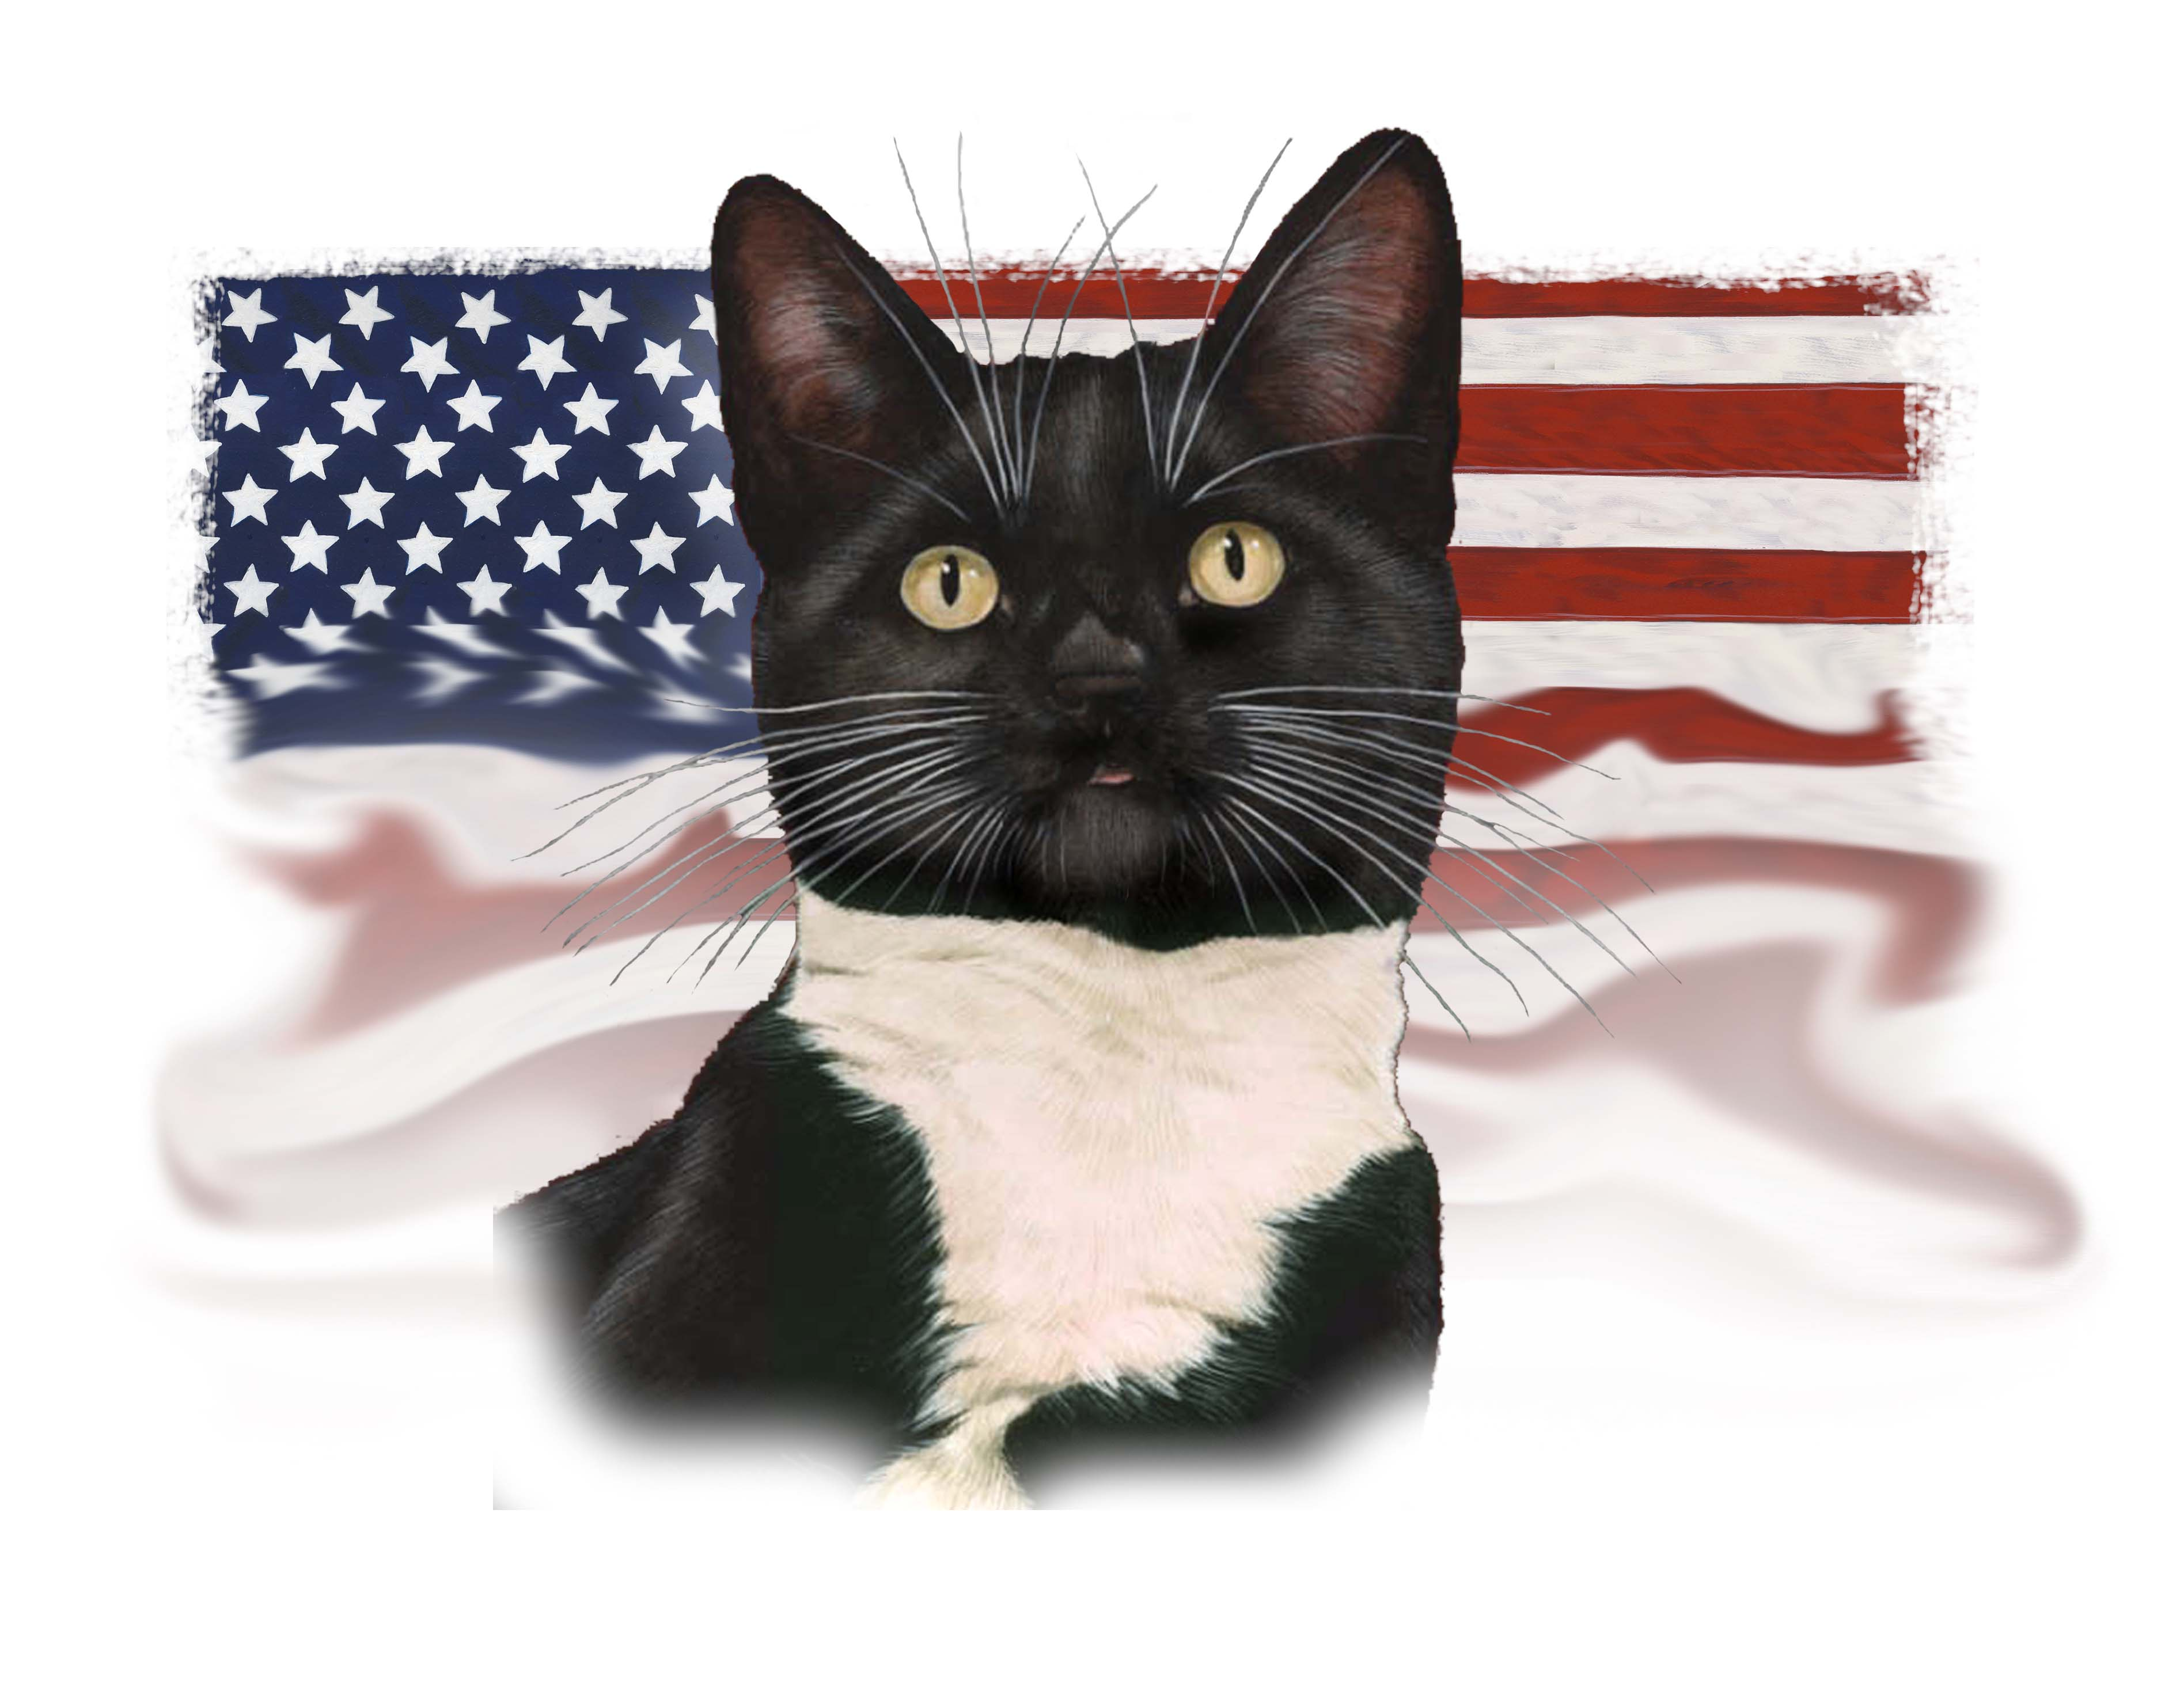
Initiative Measure To Be Submitted Directly To The Voters
The Attorney General of California has prepared the following title and summary of the chief purpose and points of the proposed measure:
TO THE HONORABLE SECRETARY OF STATE OF CALIFORNIA
We, the undersigned, registered qualified voters of California, residents of __________County, hereby propose amendment to the Health and Safety Code, relating to licensing of animals, and Petition the Secretary of State to submit the same to voters of California for their adoption or rejection at the next succeeding primary or general election, or at any special statewide election held prior to that primary or general election, or as otherwise provided by law. The proposed statutory amendment, Animal License Law reads as follows:
Section 1. Animal License Law
The state of California mandates that all cities, counties and any governmental entities within the state shall as a matter of public health not require any animal licensing or permit fees or assessment or taxes of any sort or combinations thereof to total any amount in excess of $50.00. This is a public health issue intended to encourage the licensing of pet animals requiring rabies vaccinations. Senior citizens or individuals receiving MediCare or Medi-Cal benefits shall be entitled to a reduced rate of one half of the licensing or permit fee. Cities and Counties and other governmental entities within the state of California shall not enforce or enact any law or ordinance that would remove this mandate enacted by the citizens of the state of California.
Submitted by Matt Czajkowski
Sponsored by Margaret MesserQuick
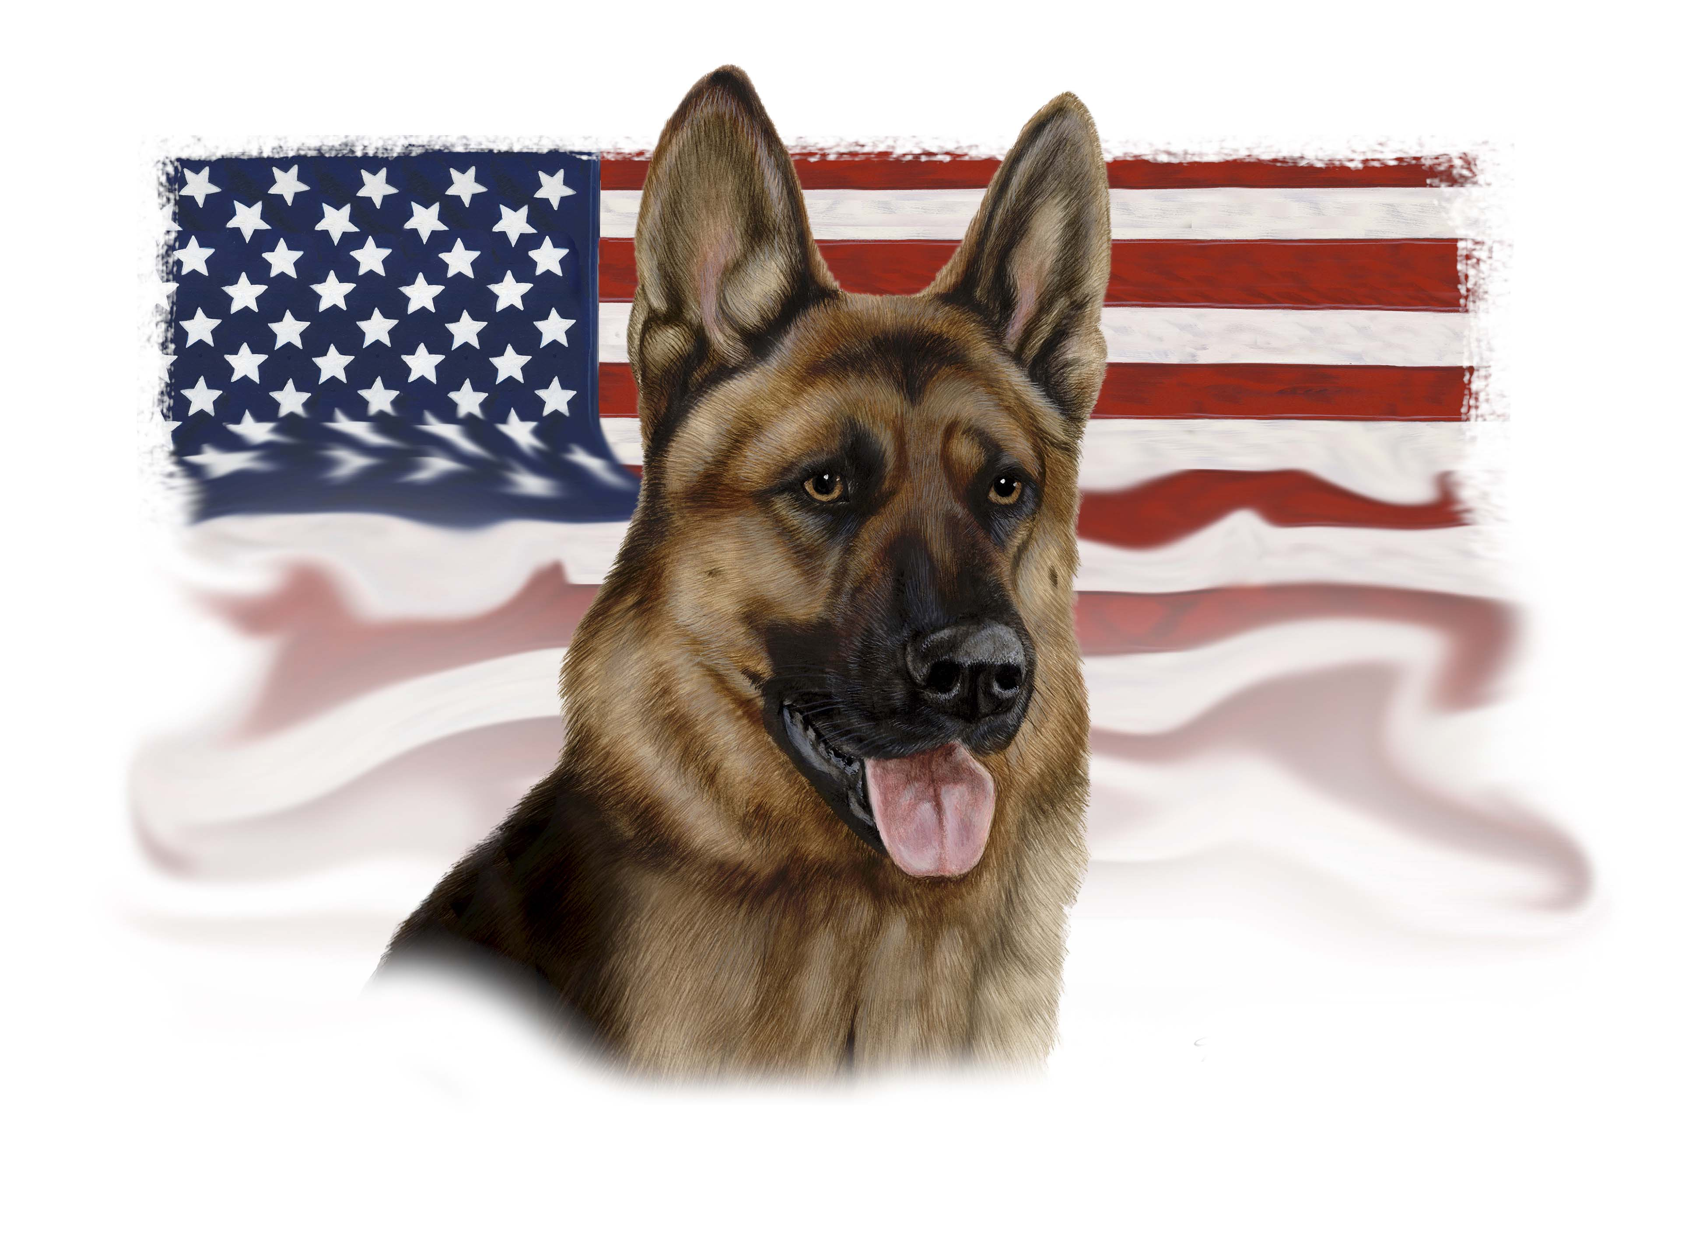
Initiative Measure To Be Submitted Directly To The Voters
The Attorney General of California has prepared the following title and summary of the chief purpose and points of the proposed measure:
TO THE HONORABLE SECRETARY OF STATE OF CALIFORNIA
We, the undersigned, registered, qualified voters of California, residents of_________________County, hereby propose measure relating to the institution of no-kill shelter policy, and Petition the Secretary of State to submit the same to voters of California for their adoption or rejection at the next succeeding primary or general election, or at any special statewide election held prior to that primary or general election, or as otherwise provided by law.
TITLE: This Act shall be called and cited as the Pet Animal Protection Act.
Section 1. PURPOSE AND INTENT - It is the intent of the people of California to end the killing of savable animals in the state. In order to accomplish this, the people find and declare:
(a) Protecting animals is a legitimate and compelling public interest.
(b) The killing of savable animals in city and county shelters is a needless tragedy that must be brought to an end.
(c) No animal should be killed if the animal can be placed in a suitable home, if a private sheltering agency or rescue group is willing to take care and custody of the animal for purposes of adoption, or, in the case of feral cats, if they can be sterilized and released to their habitats.
(d) Animals held in shelters deserve proper care and humane treatment including prompt veterinary care, adequate nutrition, shelter, exercise, environmental enrichment, and water.
(e) Shelters have a duty to make all savable animals available for adoption for a reasonable period of time.
(f) Owners of lost animals should have a reasonable period of time within which to redeem their animals without undue impediment.
(g) Shelters should not kill savable animals at the request of their owners.
(h) All efforts should be made to encourage the voluntary spaying and neutering of animals.
(i) Government is obligated to taxpayers and community members to spend tax monies on programs and services whose purpose is to save and enhance the lives of animals.
(j) When animals are killed, it should be done as humanely and compassionately as possible.
(k) Taxpayers and community members deserve full and complete disclosure about how animal shelters operate.
(l) Citizens have a right to ensure agencies follow the law.
(m) Saving lives of animals, identifying and eliminating neglect and abuse, and protecting public safety are compatible interests.
(n) Policies that undermine the public’s trust should be eliminated.
Section 2. The people of California further find and declare that all public sheltering agencies that operate within the state shall:
(a) Be open to the public for adoption seven (7) days a week.
(b) Implement programs to save lives, including free and low-cost spay/neuter services for animals, including feral cats; a foster-care network for animals needing special care, including unweaned, traumatized, sick and injured animals; comprehensive adoption programs that operate weekend and evening hours and include adoption venues other than the shelter; medical and behavioral rehabilitation programs; pet-retention programs to solve medical, environmental and behavioral problems and keep animals with their caring and responsible owners; and volunteer programs to help socialize animals, promote adoptions, and assist in the operations of the shelter.
( c) Animal control officers that handle animals shall successfully complete
(1) forty (40) hours of animal behavioral science course study;
(2) certification within one year after hire as canine trainers in one or more of the following disciplines: law enforcement, search and rescue, substance or explosive detection, therapy, assistance, guide, obedience or agility at a state or federal certified educational facility or state certified program and pass a state administered examination which includes at least 25 questions on state animal law, regulations, and procedure.
(d) Animal control clerical and administrative officers that do not handle animals shall complete four (4) hours of community relations courses every year at a state certified educational facility and pass a state administered examination which includes at least 25 questions on state animal law, regulations and procedure.
Section 3. The people of California further find and declare that ending the killing of savable animals will occur when all public and private sheltering agencies and rescue groups work together to achieve this goal, and therefore expects private sheltering agencies and rescue groups to:
(1) Be open to the public during hours that permit working people to adopt animals during non-working hours;

(2) Implement programs to save lives, including free and low-cost spay/neuter services for animals, including feral cats; a foster-care network for animals needing special care, including unweaned, traumatized, sick and injured animals; comprehensive adoption programs that operate weekend and evening hours and include adoption venues other than the shelter; medical and behavioral rehabilitation programs; pet-retention programs to solve medical, environmental and behavioral problems and keep animals with their caring and responsible owners; and volunteer programs to help socialize animals, promote adoptions, and assist in the operations of the shelter.
(3) Re-organize budgets through efficient management of operations and staffing of public shelters to reflect new fiscal priorities as stated in this Act without increasing any state, county or local tax based funding excluding annual adjustment for inflation.
Section 4. DEFINITIONS – For the purposes of this Act, the following definitions shall apply:
(1) a "Public Sheltering Agency" is a public animal care and control shelter or private shelter, society for the prevention of cruelty to animals, humane society, or animal adoption group that receives city, county or state funding and/or has a contract with a governmental entity
under which it accepts stray or owner-relinquished animals.
(2) a "Private Sheltering Agency" is a shelter, society for the prevention of cruelty to animals, humane society, or animal adoption group, which is designated as a non-profit under Section 501 ( c ) (3) of the Internal Revenue Code, and (a) does not receive any governmental funding or have a contract with the city under which it accepts strays or owner-relinquished animals; (b) accepts animals into a physical facility other than a private residence; and ( c) places into new homes stray and/or animals that have been removed from a public or private sheltering agency.
(3) a "Rescue Group" is a collaboration of individuals not operated for a profit, whose primary stated purpose is animal protection, which places into new homes stray and/or owner-relinquished animals and/or animals that have been removed from a public or private sheltering agency.
(4) an "Animal" is any non-human living creature normally kept as a pet, or a feral cat.
(5) an "Impounded" animal is an animal who enters a public or private sheltering agency or rescue group regardless of whether the animal is a stray, owner-relinquished, seized, taken into protective custody, transferred from another private or public sheltering agency, or is an animal whose owner requests that the animal be killed, except for any animal presented to a medical clinic associated with such agencies for purposes of preventative or rehabilitative care, or
sterilization.
(6) A "Stray" animal is any animal who is impounded without a known owner present at impound who is voluntarily relinquishing possession.
(7) A "Savable" animal is any animal who is either healthy or treatable, and is not a vicious or dangerous dog.
(8) A "Healthy" animal is any animal that is not sick or injured.
(9) A "Treatable" animal is any animal who is sick or injured, whose prognosis for rehabilitation of that illness and/or injury is excellent, good, fair or guarded as determined by a veterinarian licensed to practice in California.
(10) A "Non-rehabilitatable" animal is any animal with severe illness or injury whose prognosis for rehabilitation is either poor or grave as determined by a veterinarian licensed to practice in California.
(11) An "Irremediably Suffering" animal is any animal with a medical condition who has a poor or grave prognosis for being able to live without severe, unremitting pain, as determined by a veterinarian licensed to practice in this state.
(12) a "Feral Cat" is a cat that is free-roaming, unsocialized to humans, and unowned.
(13) a "Feral Cat Caregiver" is someone who cares for feral cats and has an interest in protecting the cats, but is not the owner of those cats.
(14) an "Unweaned" animal is any neonatal animal who, in the absence of his/her mother, requires supplemental bottle feeding by humans in order to survive. In the case of puppies and kittens, unweaned animals are animals that fit the above description and are from 0 to 4 weeks of age.
(15) a "Litter" of animals includes two or more animals who are under twelve weeks of age as determined by a veterinarian licensed to practice medicine in this state, or by a veterinary assistant working under the direction of a veterinarian licensed to practice medicine in the state of
California.
(16) a "Vicious Dog" is a dog who exhibits aggression to people even when the dog is not hungry, in pain, or frightened, and whose prognosis for rehabilitation of that aggression is poor or grave as determined by a trained behaviorist who is an expert on canine behavior.
(17) a "Dangerous Dog" is a dog adjudicated to be vicious by a court of competent jurisdiction and where all appeals of that judicial determination have been successful.
Section 5. STERILIZATION REQUIREMENTS – Except as otherwise provided in this section, no public or private sheltering agency or rescue group shall sell, adopt, or give away to a new owner any dog, cat, rabbit who has not been sterilized except as follows:
(a) If a veterinarian licensed to practice veterinary medicine certifies that an animal is too sick or injured to be spayed or neutered, or that it would otherwise be detrimental to the health of the animal, the adopter or purchaser shall pay the public or private sheltering agency or rescue group a deposit of not less than fifty ($50.00) dollars, and not more than one hundred ($100.00) dollars. This deposit shall be returned if the adopter or purchaser presents the entity from which the animal was obtained with proof that the animal has been spayed or neutered within sixty (60) days of receiving the animal, or presents a signed letter from a veterinarian licensed to practice medicine in the state of California, certifying that the animal has died, including a description of the animal and the most likely cause of death. This deposit shall also be returned upon the expiration of the sixty (60) day period if the adopter or purchaser presents a signed letter from a veterinarian licensed to practice medicine in this state, certifying that upon the expiration of the sixty (60) day period, the animal remains too sick or injured, or that it would otherwise be detrimental to the health of the animal, to be sterilized.
(b) The adopter or purchaser must spay or neuter that animal within sixty (60) days of adoption, purchase, or receipt from a public or private sheltering agency, or rescue group, except as follows:
(1) If a veterinarian licensed to practice medicine in this state certifies that an animal is too sick or injured or that it would otherwise be detrimental to the health of the animal to be sterilized within the time period, such animal shall be spayed or neutered within thirty (30) days of the veterinarian certifying that the animal may be safely spayed or neutered.
(c) Notwithstanding subsection (b), if a veterinarian licensed to practice medicine certifies that an animal is too sick or injured to be spayed or neutered, or that it would otherwise be detrimental to the health of the animal to be spayed or neutered, and that the animal is not likely to ever be healthy enough to be spayed or neutered, no deposit shall be required.
(d) For purposes of this section, a determination that a dog or cat is too sick or injured to be spayed or neutered, or that it would otherwise be detrimental to his or her health, may not be based solely on the youth of the dog or cat, so long as the dog or cat is at least 8 weeks of age.
(e) Notwithstanding the other requirements of this section, animals may be transferred to organizations listed on the registry required under Section 9 before they have been spayed or neutered and without a spay/neuter deposit, as long as the receiving organization represents that it will spay or neuter all animals before placing them into homes.
(f) Any funds from unclaimed deposits may pursuant to this section shall be expended only for programs to spay and neuter animals.
(g) A licensed veterinarian shall perform spay/neuter operation under this Act.
Section 6. [A]. A person is subject to civil penalties of not less than two hundred ($200.00) dollars or more than five hundred ($500.00) dollars or 40 hours of community service at a local public shelter if that person does any of the following:
(1) falsifies any proof of spaying or neutering submitted for the purpose of compliance with this Act;
(2) Intentionally issues a check for insufficient funds for any spaying or neutering deposit required under this Act;
(3) Falsifies a signed letter from a veterinarian submitted for the purpose of compliance with this Act, certifying that an animal is too sick or injured to be spayed or neutered;
(4) Fails to sterilize an animal as required.
(5) Falsifies reports of animal abuse or neglect.
[B]. An action for a penalty proposed under this section may be commenced in a court of competent jurisdiction by an administrator of the public or private sheltering agency or rescue group from which the recipient obtained the animal who is the subject of the violation.
[C]. All penalties collected under this section shall be retained by the agency bringing the action under subsection [B] to be used solely for programs to spay or neuter animals.
Section 7. FERAL CATS
(a) Caretakers of feral cats shall be exempted from any provisions of law proscribing the feeding of stray animals, requiring of permits for the feeding of animals, requiring the confinement of cats, or limiting the number of animals a person can own, harbor, or have custody of, except as follows:
(1) Nothing in this subsection shall be construed to limit the enforcement of a statute having its effect the prevention or punishment of animal neglect or cruelty, so long as such enforcement is based on the conditions of animals and imminent peril of death or injury of animal(s) or under state quarantine regulations, and not based on the mere fact that a person is feeding feral cats in a public or private location.
(b) In order to encourage spay/neuter of feral cats and to protect cats, public or private sheltering agencies or rescue groups shall not lend, rent, or otherwise provide traps to the public to capture cats, except to a person for the purpose of catching and reclaiming that person’s wayward cat (s), to capture injured or sick cats or cats otherwise in danger, to capture feral kittens for purposes of taming and adoption, or, in the case of feral cats, for purposes of spay/neuter and subsequent re-release;
(1) For purposes of this subsection, the mere location of the cats, without more, does not constitute "otherwise in danger";
(2) A person is subject to civil penalties of not less than two hundred ($200.00) dollars or more than a five hundred ($500.00) dollars or 40 hours of community service at a local public shelter if that person uses a trap from a public or private sheltering agency or rescue group for purposes other than those enumerated above.
(c) An action for a penalty proposed under this section may be commenced in a court of competent jurisdiction by an administrator of the public or private sheltering agency or rescue group from which the recipient obtained the trap that is the subject of the violation.
(d) All penalties collected under this section shall be retained by the agency bringing the action under subsection (c) to be used solely for programs to spay and neuter animals.
SECTION 8. HOLDING PERIODS
(A) The required holding periods for a stray animal impounded by any public or private sheltering agency shall be five (5) business days, not including the day of impoundment, unless otherwise provided in this section:
(1) Stray animals without any form of identification and without a known owner shall be held for owner redemption during the first two (2) days of the holding period, not including the day of impoundment, and shall be available for owner redemption, transfer, and adoption for the remainder of the holding period and a clear photo and description of animal which said animal shall be identified by possible breed(s) and shall include the pre-fix "mixed" unless any registry documentation is available and all such documentation shall be included with animal upon adoption, transfer or release of animal, and all logistical data pertinent to animal’s origin shall be posted immediately upon impound of animal on the agency’s website, and for the duration of impoundment and cannot be transferred to a location more than 50 miles from the origin of impound;
(2) Stray animal may be adopted into new homes or transferred to a rescue group or private sheltering agency for the purpose of adoption after the first two (2) days of the holding period, not including the day of impoundment, except as provided in subsections (3) to (9);
(3) If a stray animal is impounded with a license tag, microchip, tattoo or other form of identification, or belongs to a known owner, the animal shall be held for owner redemption during the first three days of the holding period, not including the day of impoundment, and shall be available for owner redemption, transfer, and adoption for the remainder of the holding period and a clear photo, description of animal which said animal shall be identified by possible breed(s) and shall include the pre-fix "mixed" unless any registry documentation is available and all such documentation shall be included with animal upon adoption, transfer or release of animal and all logistical data pertinent to animal’s origin shall be posted immediately upon impound of animal on the agency’s website and for the duration of impoundment and there shall be no transfer to any other facility or agency until seven (7) days after first day of impoundment and all efforts to locate owner have been exhausted;
(4) Litters of animals or individuals members of a litter of animals, including the nursing mother, and unweaned animals may be transferred to a private sheltering agency or rescue group immediately after impound;
(5) Individual members of litters of animals who are at least six weeks of age and without owner, including the mother, may be adopted immediately upon impound;
(6) A feral cat caregiver has the same right of redemption for feral cats as an owner of a pet cat, without conferring ownership of the cat (s) on the caregiver; with no fee assessed;
(7) Irremediably suffering animals shall be euthanized without delay, upon a determination made in writing and signed by a veterinarian licensed to practice medicine in the state of California. That certification as well as record of the origin and circumstance of impoundment of said animal shall be made available for free public inspection for no less than three (3) years;
(8) Dogs and cats with confirmed cases of parvovirus or cats with confirmed cases of panleukopenia may be euthanized without delay, upon a certification made in writing and signed by a veterinarian licensed to practice medicine in the state of California. That certification as well as record of the origin of said animal shall be made available for free public inspection for no less than three (3) years.
(9) Unweaned animals impounded without their mother cannot be killed and said shelter shall exhaust all efforts to place said animals in foster care, make emergency appeals under the requirements of Section 9, and provide feeding and care utilizing shelter personnel and/or volunteers if all resources are exhausted.
(B) The required holding period for an owner relinquished animal impounded by public or private sheltering agencies shall be the same as that for stray animals and applies to all owner relinquished animals, except as follows:
(1) Any owner-relinquished animal that is impounded shall be held for adoption or for transfer to a private sheltering agency or rescue group for the purpose of adoption for the entirety of the holding period;
(2) Owner-relinquished animals may be adopted into new homes or transferred to a private sheltering agency or rescue group for the purpose of adoption at any time after impoundment without delay with the exception of a dog that has bitten a human and therefore
must be humanely euthanized;
(C)When an animal is surrendered or brought to a shelter to be killed at the owner’s request, the animal shall be subject to the same holding periods and the same requirements of all owner relinquished animals notwithstanding the request.
(D) An animal shall not be seized by an officer of a public or private sheltering agency unless under the provisions of a state statute, within full due process and the animal is in imminent peril of death or injury or under state quarantine regulations. Said animal shall be impounded and held as consistent with the requirements of those laws, except as follows:
(1) Where any statute under the provisions of those laws due to public safety permits a holding period, care, or disposition which affords an animal less protection than the mandates of this Act, this Act shall supersede those specific provisions regarding holding, care and disposition.

SECTION 9. ANIMAL CARE STANDARDS
(a) Except as otherwise provided in this section, public and private sheltering agencies shall provide all animals during the entirety of their shelter stay with fresh food; fresh water; environmental enrichment to promote their psychological well-being such as socialization, toys and treats; and exercise and training as appropriate; however, never less than once daily, except as follows:
(1) Dogs who are vicious to people or dangerous dogs may, but are not required to, be exercised during the holding period or animals under state regulation quarantine.
(b) Notwithstanding subsection (a), public and private sheltering agencies shall work with a veterinarian licensed to practice in the state of California to develop and follow a care protocol, which is consistent with the goals of this Act as defined in Section 1, for animals with special needs such as, but not limited to, nursing mothers, unweaned animals, sick or injured animals, geriatric animals, animals needing therapeutic exercise and quarantined animals. This care protocol shall specify any deviation from the standard requirements of subsection (a) and the reasons for the deviation (s).
( c ) During the entirety of their shelter stay, animals shall be provided prompt and necessary cleaning of their cages, kennels, or other living environments no less two times per day, to ensure environments that are welcoming to the public, hygienic for both the public and animals, and to prevent disease. This cleaning shall be conducted in accordance with a protocol developed in coordination with a California licensed veterinarian, provided as follows:
(1) Animals shall be temporary removed from their cages, kennels, or other living environments during the process of cleaning, to prevent them from being exposed to water from hoses or sprays, cleaning solutions, detergents, solvents, and/or chemicals.
(d) During the entirety of their shelter stay, all animals shall be provided with prompt and necessary veterinary care, including but not limited to preventative vaccinations, cage rest, fluid therapy, pain management, and/or antibiotics, sufficient to alleviate any pain caused by disease or injury, to prevent a condition worsening, and to allow them to leave the shelter in reasonable condition, even if the animals are not candidates for redemption, transfer or adoption.
(e) Public and private sheltering agencies shall work with a California licensed veterinarian to develop and follow a protocol to prevent the spread of disease, including, but not limited to, appropriate evaluation and testing of newly impounded animals, administration of vaccines, proper isolation and handling of sick animals, and measures to protect those animals most vulnerable to infection.
Section 10. Additional Programs and Duties
(a) All public and private sheltering agencies that kill animals shall maintain a registry of organizations willing to accept animals for the purposes of adoption, as follows:
(1) All public or private sheltering agencies, and rescue groups designated as non-profits by Section 501 ( c)(3) of the Internal Revenue Code, shall be immediately placed on this registry upon their request, regardless of the organizations’ geographical location or any other factor except as described under subsection (a) (5).
(2) The public or private sheltering agency may, but is not required to, include on the registry any rescue groups that are not designated as non-profits under IRS section 501 (c)(3).
(3) The registry shall include the following information as provided by the registered organizations: organization name, mailing address, and telephone number; website and e-mail address, if any; emergency contact information for the organization; the types of animals about whom the organization wishes to be contacted, including species type and breed; and whether or not the organization is willing to care for unweaned, sick or injured animals, and/or feral or aggressive animals.
(4) All public and private sheltering agencies shall seek organizations to include on the registry.
(5) A public and private sheltering agency may refuse to include an organization on the registry or delete it from the registry, until such time the case, if any of the organization’s current directors and/or officers have been convicted in a court of competent jurisdiction of a crime consisting of cruelty to animals or neglect of animals; or if that organization or its current directors or officers are constrained by a court order or legally binding agreement that prevents the organization from taking in or keeping animals. An agency may require an organization to disclose any and all convictions and legal impediments described in this subsection.
(6) A public and private sheltering agency may require that registering organizations provide the following summary information on no more than a monthly basis: the total number of animals the organization has taken from the agency who have been adopted, died, were transferred, were killed, and are still under the organization’s care. This information may be provided in an informal format, such as electronic mail. Such information shall be made available to the public.
(7) A public and private sheltering agency shall not demand additional information, other than that described in this section, as a prerequisite for including an organization on the registry or for continuing to maintain that organization on the registry.
(b) No public and private sheltering agency may kill an animal unless and until the agency has notified, or made a reasonable attempt to notify, all organizations on the registry described in subsection (a) that have a willingness to take an animal of that type.
(1) Such notification must take place at least two (2) business days prior to the killing of the animal.
(2) At a minimum, such notification shall include calling the organization’s regular and emergency contact numbers, and sending an email to its email address, if any. All notifications will be duly noted on the animal in question’s final disposition record.
(3) No animal may be killed if an organization is willing and able to take the animal within two (2) business days after being notified.
(4) No fee may be assessed for animals released to organizations listed on the registry at time of receipt. However, all sales, or adoption fees, of animals acquired by the registry organization from public and private sheltering agencies will deposit a sum equal to 10% of said sales or adoption fee into a spay/neuter fund of the public or private sheltering agency to be used for spay/neuter programs.
(c) No public and private sheltering agency may kill an animal unless and until the agency has notified, or made a reasonable attempt to notify, individual rescuers, rescue groups who are not designated as a non-profit under IRS Section 501 (c)(3), and the public at large so that they may consider adopting or rescuing the animal consistent with the agency’s normal adoption or transfer protocols.
(1) Such notification must take place at least two (2) business days prior to the killing of the animal.
(2) Such notification can be accomplished in any manner reasonably likely to lead to lifesaving, but must, at a minimum, include posting a notice in the shelter on the particular animal’s cage or kennel, and on the agency’s website that states: "This animal is to be killed on [date] and [time]. This includes posting on the agency’s website with animal’s photo and description.
(d) The following exceptions shall apply to the requirements of subsections (b) and (c):
(1) All irremediably suffering animals shall be euthanized without delay. The determination that an animal is irremediably suffering shall be made in writing by a California licensed veterinarian, and made available for free public inspection for no less than three (3) years.
(2) Dogs and cats with confirmed cases of parvovirus or distemper or cats with confirmed cases of panleukopenia may be euthanized without delay, upon certification by a California licensed veterinarian. Such certification will be made available for free public inspection for no less than three (3) years.
(3) Dangerous dogs may, but not are required to, be released to organizations on the registry.
(4) Upon the impoundment of unweaned animals without their mother, all public and private sheltering agencies which have not placed the animals into foster care or have not committed to provide supplemental feeding shall immediately make an emergency appeal to organizations on the registry that have indicated that they are willing and able to care for unweaned animals, and give such organizations a reasonable amount of time to respond to the appeal. If no foster care is found, agency will delegate personnel from other assignments to provide shifts for feeding and care to unweaned animals.
(e) A public and private sheltering agency shall require organizations taking animals under this section to sign a contract providing:
(1) That the animals are being taken for the purposes of adoption;
(2) That all animals taken from the agency will be spayed or neutered before adoption, unless California licensed veterinarian certifies that an animal is too sick to be spayed or neutered or that it would otherwise be detrimental to the health of the animal to be sterilized as required under Section 3 of this Act.
(f) All public and private sheltering agencies shall maintain and up-date daily on their website all written and signed reports of lost animals provided by the owners either in person, via facsimile or via First Class mail for a period of not less than one (1) month and shall facilitate reunion expeditiously.
SECTION 11. All public and private sheltering agencies shall take appropriate action to ensure that all animals are checked for all methods of identification, including microchips, identification tags, licenses and tattoos. All public and private sheltering agencies shall maintain continuously updated lists of animals reported lost, and attempts to match these lost reports with animals found and animals in the shelter, and shall also post all stray animals on the Internet with sufficient detail to allow them to be recognized and claimed by their owners. All impounded animals shall include a descriptive record noting height, weight, eye and coat color, coat length, and any distinguishing white or other markings as well as a category denoting possible breed ancestry as determined by attending veterinarian. Said data base will be maintained as an electronic spreadsheet available to the public free upon request updated and copied on a back-up disk daily. If a possible owner is identified, the agencies shall undertake reasonable efforts to notify the owner or caretaker of the whereabouts of the animal and any procedures available for the lawful recovery of the animal. These efforts shall include, but are not limited to, notifying the possible owner by telephone, mail, and personal service to the last known address. Upon the owner’s or caretaker’s initiation of recovery procedures, the agency shall retain custody of the animal for a reasonable period of time for completion of the recovery process. Efforts to locate or contact an owner or caretaker, and communications with persons claiming to be owners or caretakers, shall be recorded and be made available for free public inspection for no less than three (3) years.
SECTION 12. Every public or private sheltering agency shall have adoption programs which include programs to place animals into homes and to transfer animals to other private sheltering agencies or rescue groups for adoption; promotion of animals to the community through means such as local media and the Internet; evening and weekend adoption hours; and, community-based adoption events or venues at locations other than the shelter. All public sheltering agencies shall be open for public adoption seven days per week for a minimum of six (6) hours per day, except for federally recognized holidays, when the shelter may, but is not required to, be open for adoptions.
SECTION 13. No public or private sheltering agency or organization maintained on the agency registry list shall ban, bar, limit or otherwise obstruct the adoption of any animal based on arbitrary criteria, such as breed, age, color, size or any other criteria unrelated to the individual animal’s medical condition and temperament.
SECTION 14. Every public sheltering agency shall provide the following public services:
(1) low-cost spay/neuter services for animals;
(2) volunteer opportunities for people, without discrimination of any kind, nor any pre-requisite of training, courses or experience, to assist the shelter, including fostering animals, socializing animals, training animals, assisting with adoptions, and otherwise helping with general operations of the shelter, including but not limited to clerical, data entry and website updates. For every two hours of logged volunteer work, volunteers will earn fee vouchers for fifty ($50.00) dollars valid at any public shelter within the state of California for assessed fees.
(3) programs to assist people in overcoming situations that may cause them to relinquish or abandon their animals, including, but not limited to, programs that address animal behavior problems, medical conditions and environmental conditions.
SECTION 15. No savable animal in a public or private sheltering agency shall be killed simply because the holding time has expired. Before an animal is killed, all of the following conditions must be met:
(1) there are no empty cages, kennels, or other living environments in the shelter;
(2) the animals cannot share a cage or kennel with another animal;
(3) a foster home is not available;
(4) organizations listed on the registry are not willing to accept animal;
(5) the animal is not a feral cat subject to sterilization and release;
(6) all mandates, programs and services of the Act, have been met; and
(7) the director of the agency certifies in writing he or she has no other alternative.
Said determination and record of Section 15 compliance for each case shall be made available for free public inspection for no less than three (3) years.
SECTION 16. EUTHANASIA
(a) All animals impounded by a public or private sheltering agency or rescue group shall be killed, only when necessary and consistent with the requirements of this Act, by lethal intravenous injection of sodium pentobarbital, except as follows:
(1) intraperitoneal injection may be administered only by a licensed veterinarian, and only when intravenous injection is not possible for infant animals, companion animals other than cats and dogs, feral cats, or in comatose animals with depressed vascular function.
(2) intracardiac injections may be used only when intravenous injection is not possible for animals who are completely unconscious or comatose, and then only by a licensed veterinarian.
(3) any other form or method of euthanasia will be deemed an act of animal cruelty and duly reported to authorities.
(b) No animal shall be allowed to witness any other animal being killed or being tranquilized/sedated for the purpose of being killed.
( c) Animals shall be sedated/tranquilized as necessary to minimize their stress or discomfort, or in the case of vicious animals, to ensure staff safety, except as follows:
(1) neuromuscular blocking agents shall not be used.
(d) Following their injection, animals shall be lowered to the surface on which they are being held and shall not be permitted to drop or otherwise collapse without support.
(e) An animal may not be left unattended between the time procedures to kill the animal are commenced and the time death occurs, nor may the body be disposed of until death is verified.
(f) Verification of death shall be confirmed for each animal in all of the following ways:
(1) By lack of heartbeat, verified by a stethoscope;
(2) By lack of respiration, verified by observation;
(3) By pale, bluish gums and tongue, verified by observation; and
(4) By lack of eye response, verified if lid does not blink when eye is touched and pupil remains dilated when a light is shined on it.
(g) The room in which animals are killed shall be
(1) Cleaned and regularly disinfected as necessary, but no less than once per day on days the room is used;
(2) The area where the procedure is performed shall be cleaned and disinfected between each procedure;
(3) The room in which animals are killed shall have adequate ventilation that prevents the accumulation of odors, including but not limited to air purification system.
SECTION 17. PUBLIC ACCOUNTABILITY –
(a) All public and private sheltering agencies must post, in a conspicuous place where animals are being relinquished by owners, a sign which is clearly visible and readable from any vantage point in the area, and at least 17 inches by 22 inches, which has all the information identified by species type:
(1) the number of animals impounded for the prior calendar year;
(2) the number of animals impounded for the prior calendar year which were adopted;
(3) the number of animals impounded for the prior calendar year which were transferred to other agencies for adoption;
(4) the number of animals impounded for the prior calendar year which were reclaimed by their owners;
(5) the number of animals impounded for the prior calendar year which died, were lost, or were stolen while under the direct or constructive care of the agency; and
(6) the number of animals impounded for the prior calendar year which were killed by the agency, at the agency’s direction, with agency’s permission, and/or by representative of agency.
(b) All public or private sheltering agencies must provide all owners who are relinquishing an animal with accurate information, in writing, about the likely disposition of their animal, but is not limited to: (1) if the animal is the breed or type who is normally killed, (2) if the animal is likely to be killed because of some current, usual, or unusual circumstances, and (3) the information is Section (a) (1)-(6).
(c) Any owner surrendering an animal to a public or private sheltering agency must sign a statement on a form provided by the agency which includes the specific language: "I understand that the shelter may kill my pet." The shelter or its agents must recite this statement aloud and request signature of acknowledgment by owner or if owner refuses to sign, make notation of refusal on form. Such statements must be kept on file for a period of no less than three years.
(d) All public and private sheltering agencies must make available for free public inspection the care protocol required under Section 8 (b), the cleaning protocol required under 8 (c) and the disease-prevention protocol required under Section 8 (e).
(e) All public and private sheltering agencies shall include on their web sites and post, in a conspicuous place near the entrance of the shelter, a list of organizations included on the registry described in Section 9, as well as an invitation for all public and private sheltering agencies to inquire about being listed on the registry, so that they may be notified before any animal is killed. Such lists shall not include any contact information the registered organizations do not wish to make public.
SECTION 18. ACCOUNTABILITY TO STATE AND COUNTY – All public or private agencies shall provide to the City Council, the County and State Health Department, and upon request, for free public inspection, a monthly summary by the tenth day of the month and an annual summary by January 31 that includes information by species type:
(1) the number of animals impounded during the previous month/year;
(2) the number of animals impounded and sterilized and/or sterilized by contract with participating outside private veterinarians during the previous month/year;
(3) the number of animal killed by the agency, including origin and circumstance of impoundment, at the agency’s direction, with agency’s permission, and/or by representative of agency during the previous month/year;
(4) the number of animals which died, were lost, or were stolen while under the direct or constructive care of the agency during the previous month/year;
(5) the number of animals which were returned to their owners during the previous month/year;
(6) the number of animals which were adopted during the previous month/year;
(7) the number of animals who were transferred to other organizations for adoption during the previous month/year; and
(8) the specific number of animals impounded into the reporting agency from outside the city, outside the county, outside the state and outside the country during the previous month/year.
SECTION 19. DOG LICENSE REVENUES – as required under any existing state or local laws, shall be deposited into an account for use by the public animal control agency as follows:
(1) sixty (60%) percent shall be used exclusively for free and low-cost spay of feral cats and spay/neuter of owned animals under the provision of subsection (a);
(2) forty (40%) percent shall be used exclusively for free and low-cost medical assistance, including vaccinations, of feral cats and owned animals under subsection (a).
(a) These funds shall be used to provide low-cost spay/neuter and medical care for animals if the owner or feral cat caretaker meets income guidelines set by the shelter or city as follows:
(1) These funds shall be used to provide free spay/neuter for animals if the owner receives public assistance or is eligible for any type of city, county, state or federal aid of the kind that is normally given to individuals based on lack of sufficient income;
(2) These funds shall be used to provide low-cost medical care, including vaccinations, for animals if the owner receives public assistance or is eligible for any type of city, county, state or federal aid of the kind that is normally given to individuals based on lack of sufficient income;
(3) These funds shall be used to provide free spay and vaccinations against rabies for feral cats regardless of the feral cat caretaker’s income.
(b) These services shall be performed under the direction of a licensed veterinarian licensed by the State of California.
( c) These funds shall not be deducted from the agency’s city or county budget.
SECTION 20. LEGAL RECOURSE
(a) Any law, ordinance or policy which requires licensing of cats, the confinement of cats, limits the number of animals a household can own or care for, prohibits or requires permits for the feeding of stray domestic animals, or prohibits adoption of specific breeds of dogs is hereby repealed as contrary to the public interest except as follows:
(1) Nothing in this section shall be construed to limit the enforcement of a statute having as its effect the prevention or punishment of animal cruelty or neglect, so long as such enforcement is based on the conditions of the animals or the environment to the extent that the animal is placed in imminent peril of life or injury, and not based on the mere fact that a household has a certain number of animals, a person is feeding stray domestic animals, and/or a dog is of a particular breed.
(b) Any resident of the State of California, rescue group, public or private sheltering agency may compel a public or private sheltering agency or rescue group to follow the mandates of this Act through a lawsuit asking a court of competent jurisdiction to grant declaratory and injunctive relief including, but not limited to:
restraining orders, injunctions, writs of mandamus and prohibition, and other appropriate remedies which compel compliance with this Act.
SECTION 21. CONFLICTING BALLOT MEASURES – If this measure is approved by voters but is superseded by law or any other conflicting ballot measure approved by the voters at the same election that affects the protection of pet animals, the provisions of the other measure or measures shall be deemed to be in conflict with this measure. In the event that this measure receives a greater number of affirmative votes, the provisions of this measure shall prevail in their entirety, and each and every provision of the other measure or measures shall be null and void.
SECTION 22. SEVERABILITY. – If any provision of this Act, or the application thereof to any person or circumstances, is held invalid or unconstitutional, that invalidity or unconstitutionality shall not affect other provisions or applications of this Act that can be given effect without the invalid or unconstitutional provision or application, and to this end the provisions of this Act are severable.
SECTION 23. EFFECTIVE DATE – This Act becomes effective immediately upon ballot acceptance by the voters.
Submitted by A. S. Scaletti
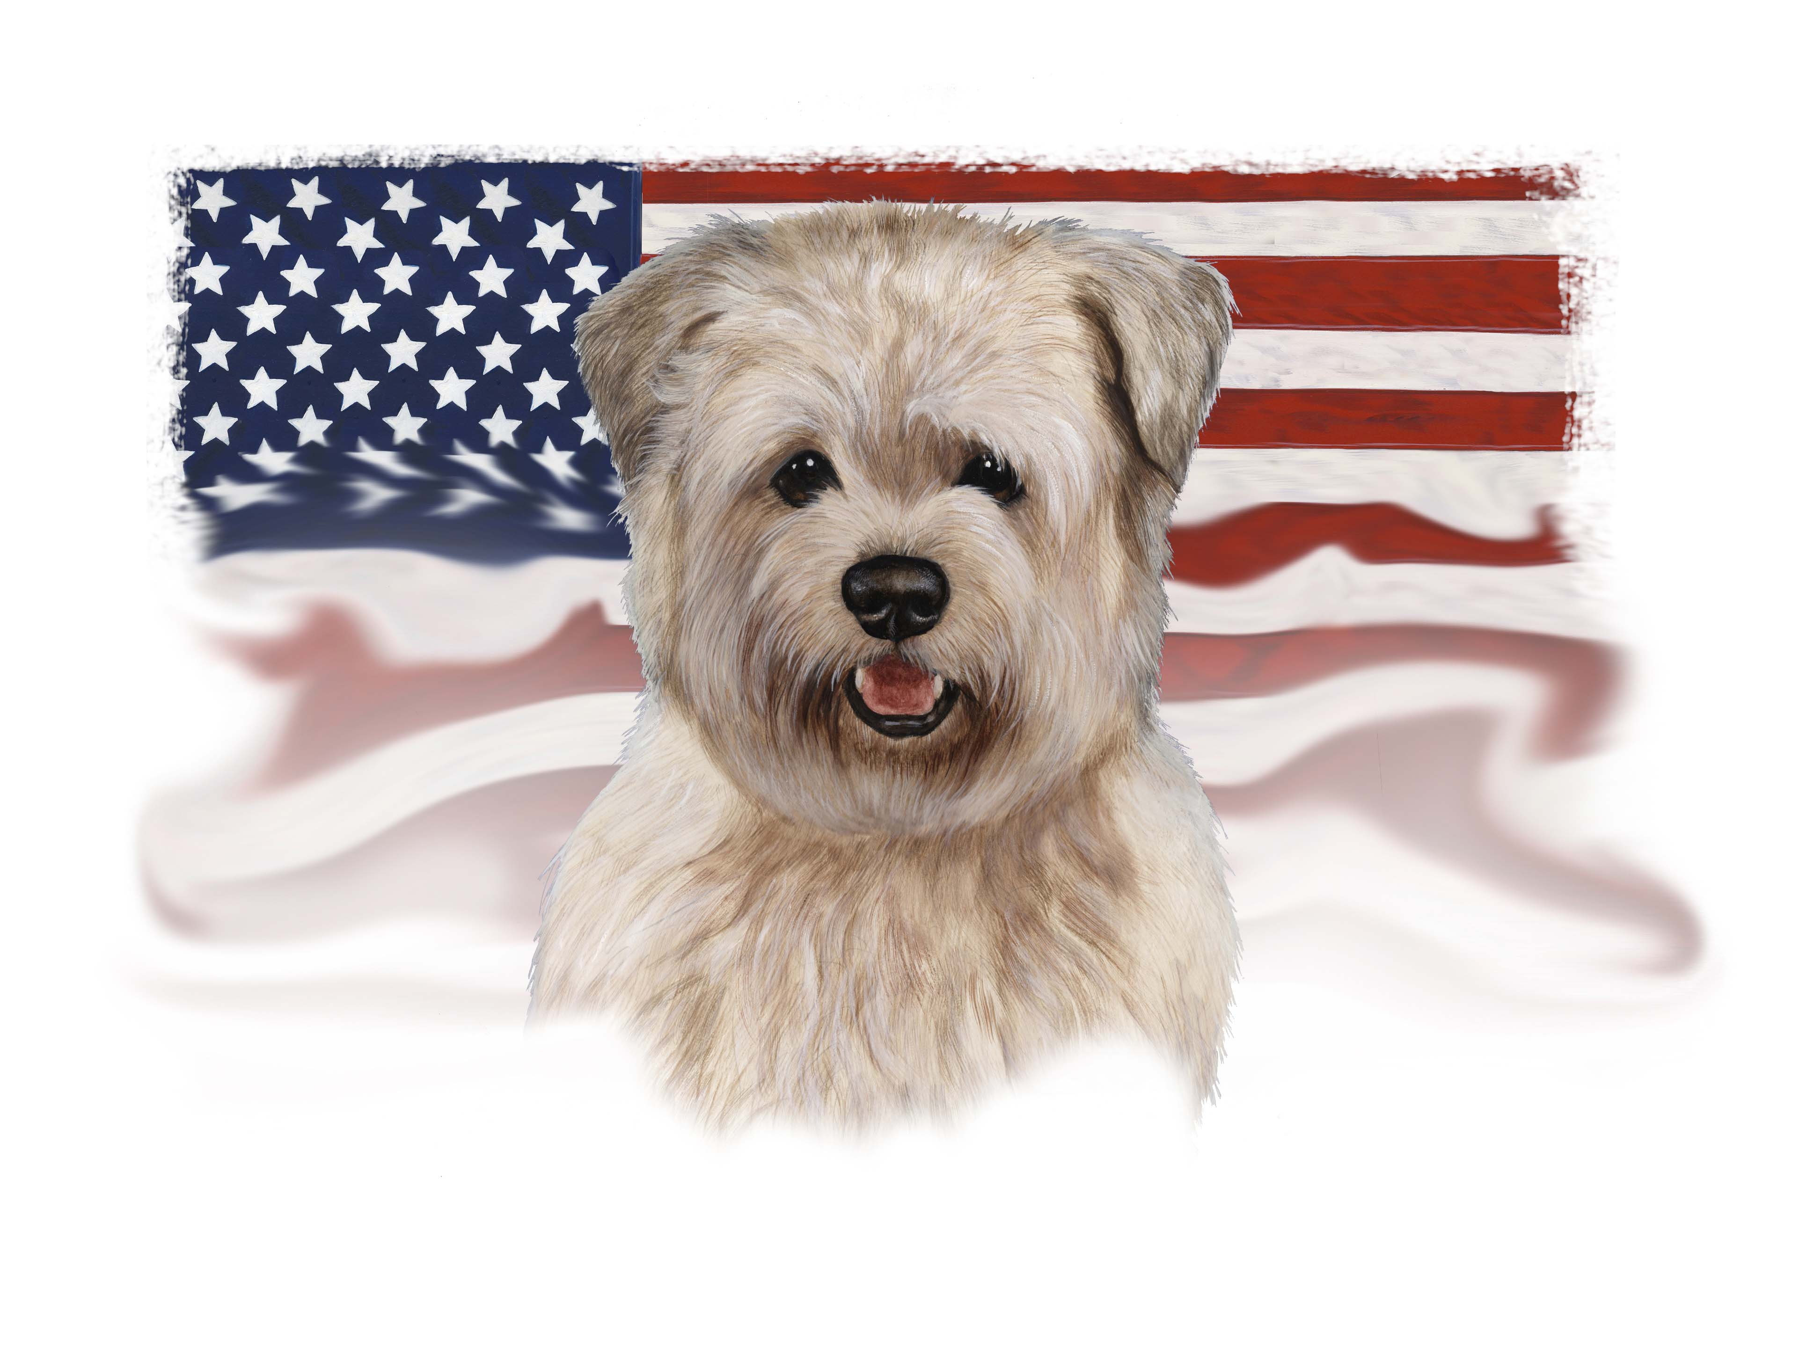
Initiative Measure To Be Submitted Directly To The Voters

The Attorney General of California has prepared the following title and summary of the chief purpose and points of the proposed measure:

TO THE HONORABLE SECRETARY OF STATE OF CALIFORNIA

We, the undersigned, registered, qualified voters of California, residents of __________________County, hereby propose amendment relating to prohibition of mandated implantation of devices in humans or animals, and Petition the Secretary of State to submit the same to voters of California for their adoption or rejection at the next succeeding primary or general election, or at any special statewide election held prior to that primary or general election, or as otherwise provided by law.

The proposed Constitutional Amendment,

CALIFORNIA CONSTITUTION - ARTICLE 1
DECLARATION
OF RIGHTS

The state of California, counties, cities, and any governmental entities within the state shall not make any law or ordinance that mandates the subcutaneous implantation of any type of information or identification chip/RFID or any other form of permanent or temporary subcutaneously implanted device or ink for any purpose in any human or animal. No one shall be denied employment, education or medical services, health plan membership or licensing or certification of any sort for refusal to be implanted with such a device. No private or governmental entity shall enforce any law or ordinance that abridges this mandate enacted by the citizens of the state of California.

This Amendment shall become effective immediately upon
approval by voters.

Submitted by Fred Hall
Sponsored by George Bell
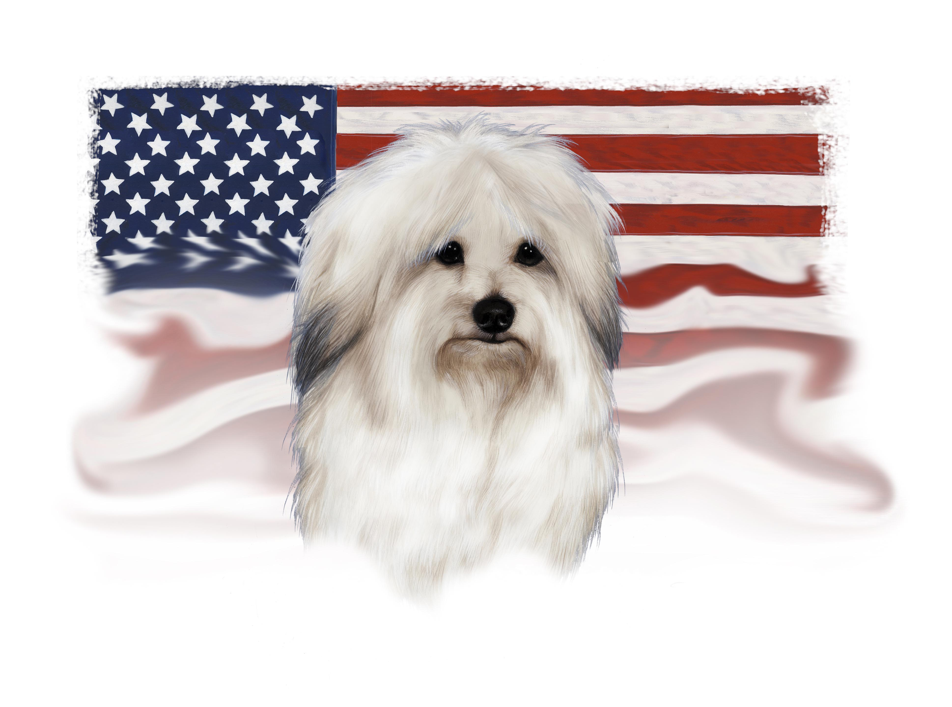
Initiative Measure To Be Submitted Directly To The Voters

The Attorney General of California has prepared the following title and summary of the chief purpose and points of the proposed measure:

TO THE HONORABLE SECRETARY OF STATE OF CALIFORNIA

We, the undersigned, registered qualified voters of California, residents of __________County, hereby propose amendment relating to property, and Petition the Secretary of State to submit the same to voters of California for their adoption or rejection at the next succeeding primary or general election, or at any special statewide election held prior to that primary or general election, or as otherwise provided by law. The proposed Constitutional Amendment, Property Protection Act:

CALIFORNIA CONSTITUTION
ARTICLE 1 DECLARATION OF RIGHTS
The State of California, counties, cities and any governmental entities within the State shall not make any law or ordinance that prevents any citizen from owning or acquiring legally, property nor shall there be a limit to the amount of property acquired, grown or produced or owned.
There shall be no law(s) or ordinance language enacted that abridge this mandate enacted by the citizens of the State of California.
Submitted by Richard Byrd
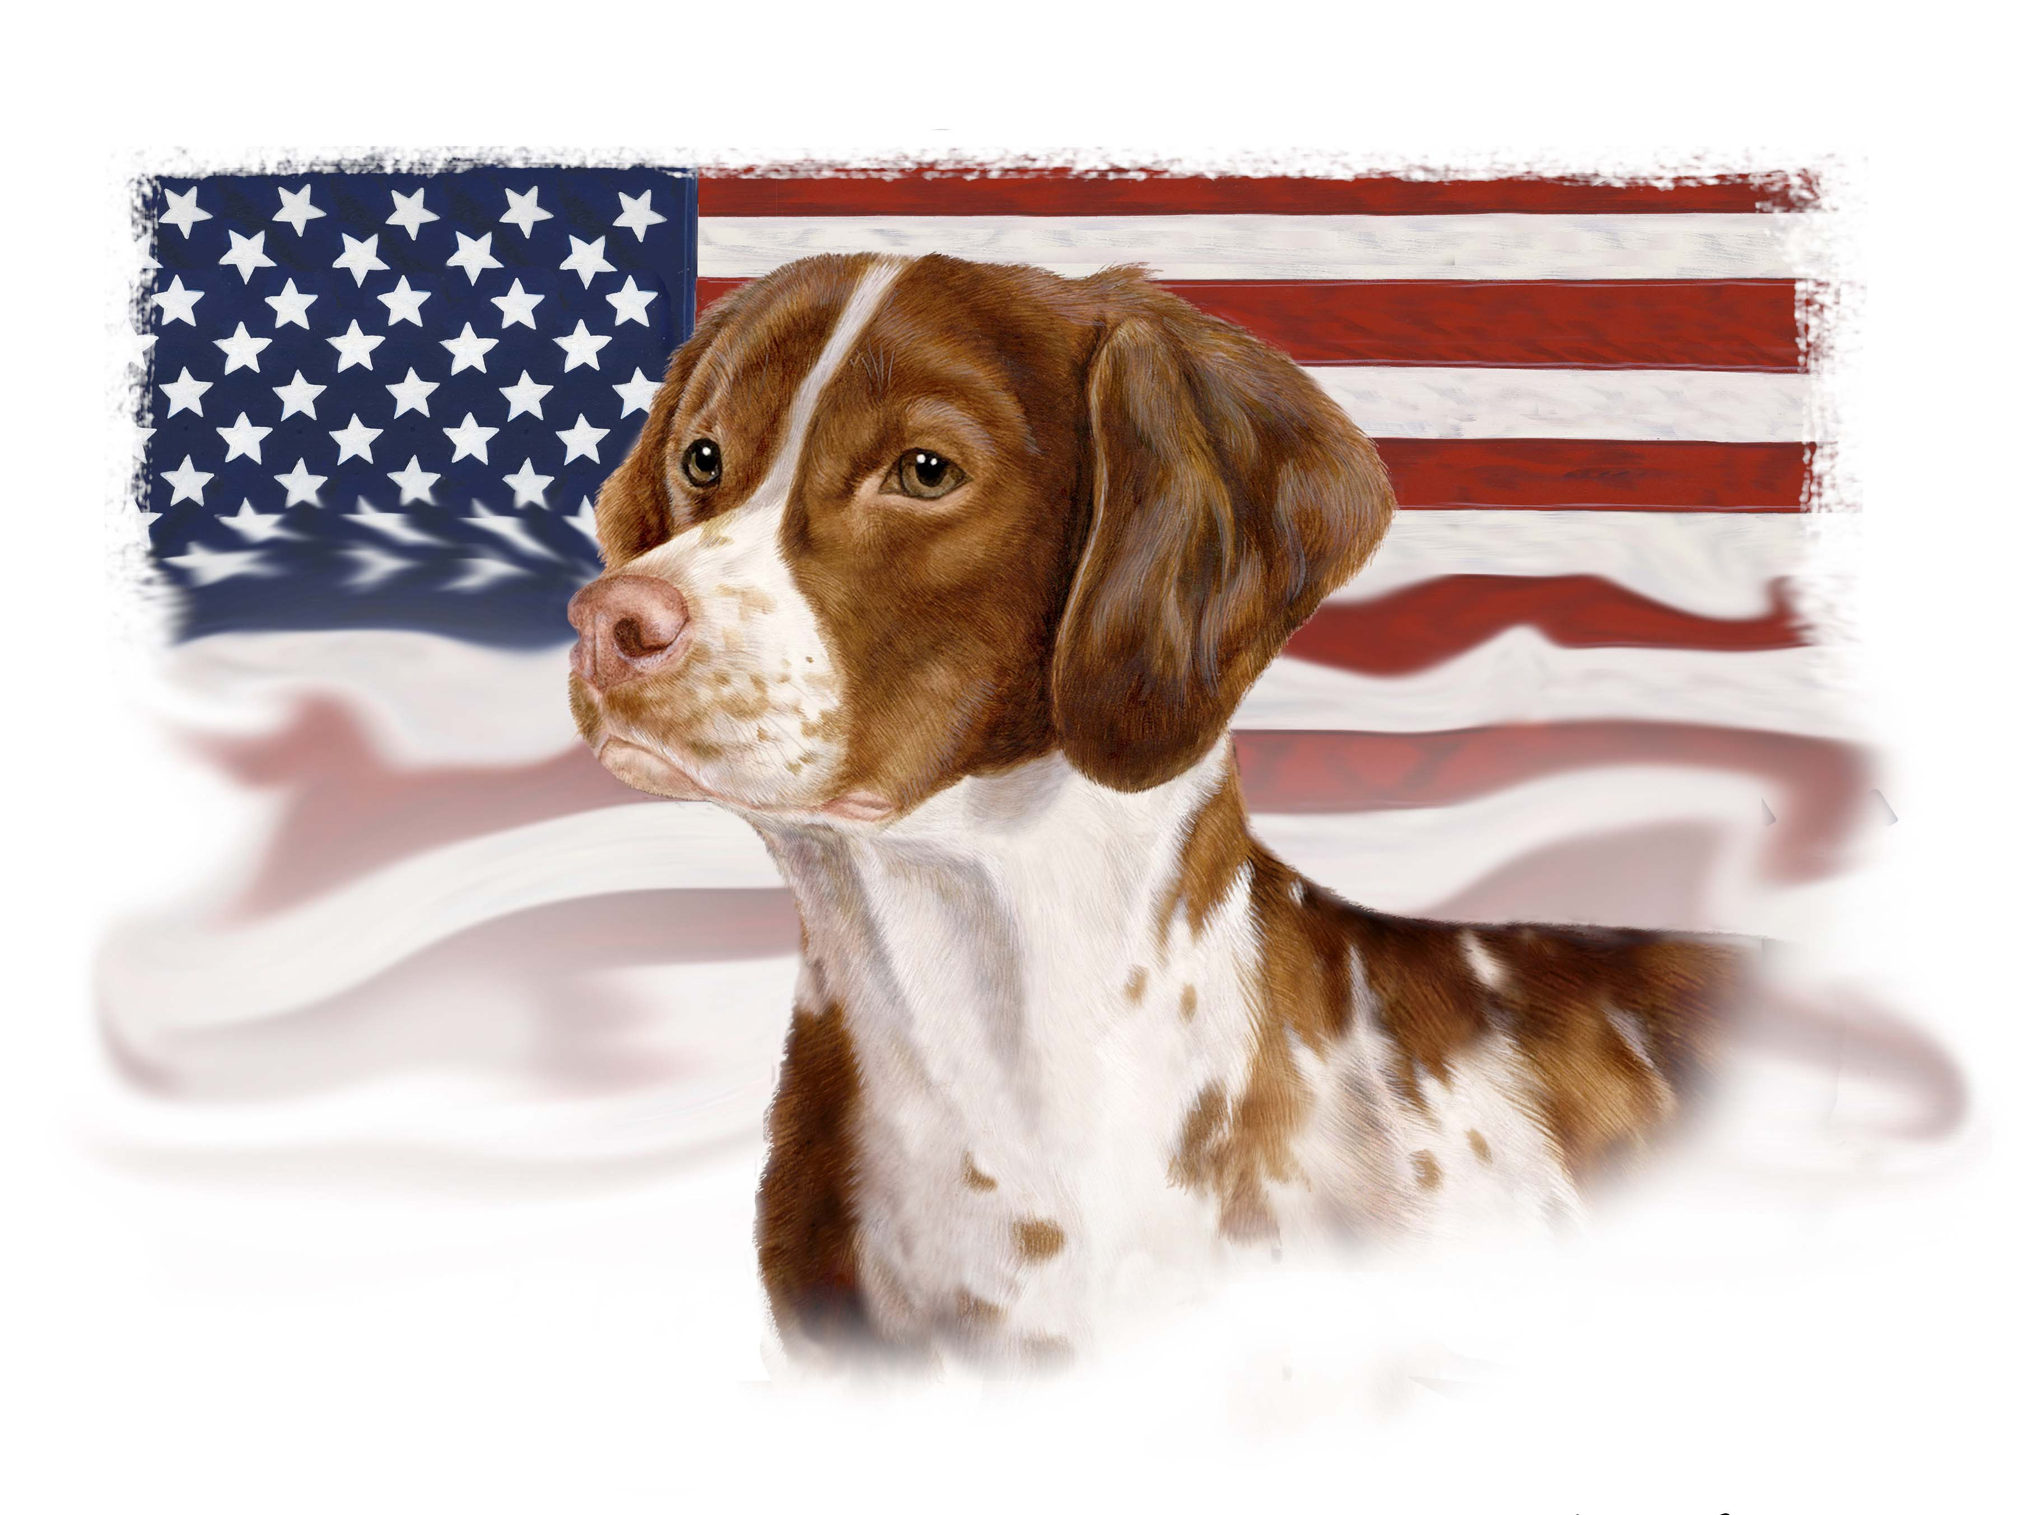
Section 1. TITLE – This Act shall be known and may be cited as Farm Animal Protection Act.

Section2. PURPOSE – The purpose of this Act is to protect farm animals in a manner that allows for the highest standards of animal husbandry as prescribed by scientific analysis and studies to prevent morbidity and mortality.

Section3. Farm Animal Confinement Provisions
Chapter 13.8 (commencing with Section 25990) is added to Division 20 of the Health and Safety Code, to read:
CHAPTER 13.8: FARM ANIMAL CONFINEMENT

25990. PROHIBITIONS.– (a) In addition to other applicable provisions of law, a person shall not tether or confine any calf raised for veal or pig during pregnancy, on a farm, for all or the majority of any day in a manner that prevents such animal from lying down, standing up, and turning around freely, except where duly noted, or as recommended by an attending veterinary professional.

(b) A person shall not confine any egg laying hen except in accordance with scientifically validated standards of animal care. The California Department of Food and Agriculture shall publish regulations establishing standards for the care of laying hens in accordance with this subsection. Such standards shall provide for, but not be limited to, housing conditions, and space allowances, which shall include provisions for access to feed and water, ventilation, light, biosecurity (including limitations on movement of additional hens into a flock after the initial placement of the flock), maximum concentrations of ammonia and other gases, and other appropriate factors, and shall provide for no less than a range of 67 to 86 square inches of usable space per laying hen in conventional production systems and no less than a range of 1 to 1.5 square feet of usable space per laying hen in cage-free production systems.”

(c)The standards established under subsection (b) shall, to the extent practicable, be specific to the type of egg production undertaken by the producer, whether conventional, cage-free, free-range or organic. The standards shall also include provisions for audits and other appropriate certification procedures.

(d) Notwithstanding any other provision of this section, the California Department of Food and Agriculture shall approve and incorporate by reference into the standards established under subsection (b) any existing scientifically validated standards for animal care that advance the purpose of this section, including but not limited to the programs known as “United Egg Producers Certified” and “Certified Humane Raised and Handled,” as in effect on the date of enactment of this section. A person that cares for laying hens in accordance with the provisions of such existing scientifically validated standards of animal care shall be deemed to be in compliance with this section.

25991. DEFINITIONS.– For the purposes of this chapter, the following terms have the following meanings:
(a) “Calf raised for veal” means any calf of the bovine species kept for the purpose of producing the food product described as veal.
(b) “ Animal” means any pig during pregnancy, calf raised for veal, or egg laying hen who is kept on a farm.
(c) “Egg laying hen” means any female domesticated chicken, turkey, duck, goose, or guinea fowl kept for the purposes of egg production.
(d) “Enclosure” means any cage, crate, or other structure (including what is commonly known as a gestation crate, for pigs; a veal crate for calves; or a battery cage for egg laying hens) used to confine a covered animal.
(e) “Farm” means the land, building, support facilities, and other equipment that are wholly or partially used for the commercial production of animals or animal products used for food or fiber. This is not meant to include any personal animal production of animals or animal product for personal consumption nor any 4-H projects or other such similar project.
(f) “Pig during pregnancy” means any pregnant pig of the porcine species kept for the primary purpose of breeding.
(g) “Person” means any individual, firm, partnership, joint venture, association, limited liability company, corporation, estate, trust, receiver or syndicate.

25992. EXCEPTIONS. – This chapter shall not apply:

(a) During scientific or agricultural research.
(b) During examination, testing, individual treatment or operation for veterinary purposes.
(c) During transportation.
(d) During rodeo exhibitions, state or county fair exhibitions, 4-H programs, and similar exhibitions.
(e) During the slaughter of a covered animal in accordance with the provisions of chapter 6 (commencing with Section 19501) of Division 9 of the Food and Agricultural Code, relating to humane methods of slaughter, and other applicable law and regulations.
(f) To a pig during the seven (7) day period prior to the pig’s expected date of giving birth and until weaning of her piglets.
(g) To a calf raised for veal during its infancy.

25993 ENFORCEMENT. – Any person who violates any of the provisions of this chapter is guilty of a misdemeanor, and upon conviction thereof shall be remanded to 40 hours of animal welfare instruction at a local educational institution or agricultural extension facility and a fine not to exceed five hundred ($500) dollars.

25994. CONSTRUCTION OF CHAPTER. – The provisions of this chapter are in addition to, and not in lieu of, any other laws protecting animal welfare, including the California Penal Code. This chapter shall not be construed to limit any state law or regulations protecting the welfare of animals, nor shall anything in this chapter prevent a local governing body from adopting and enforcing its own animal welfare laws and regulations.

Section 4. CONFLICTING BALLOT MEASURES – If this measure is approved by voters but is superseded by law or any other conflicting ballot measure approved by the voters at the same election that affects the protection of farm animals, the provisions of the other measure or measures shall be deemed to be in conflict with this measure. In the event that this measure receives a greater number of affirmative votes, the provisions of this measure shall prevail in their entirety, and each and every provision of the other measure or measures shall be null and void.

Section 4. SEVERABILITY. – If any provision of this Act, or the application thereof to any person or circumstances, is held invalid or unconstitutional, that invalidity or unconstitutionality shall not affect other provisions or applications of this Act that can be given effect without the invalid or unconstitutional provision or application, and to this end the provisions of this Act are severable.

Section 5. EFFECTIVE DATES

The provisions of sections 25990, 25991, 25992, 25993, and 25994 shall become operative on January 1, 2015.

Submitted by A. S. Scaletti

